SRIRAM BALASUBRAMANIAN

It staffing USING BLOCKCHAIN

Implementation of Blockchain Technology in IT Staffing using Amazon Web Services and Bigchain Db.

- Brief Introduction to Blockchain
- A valid Blockchain is a reliable way of confirming the party submitting a record to the Blockchain, the time and date of its submission, and the contents of the record at the time of submission.
- A Blockchain is an electronic ledger (register) of digital records, events, or transactions that are represented in condensed form known as a hash (digital security feature), authenticated, and maintained through a “distributed” or “shared” network of participants using a group consensus protocol (multiple users).

Blockchain technology is already in use in the private sector, though clearly in the early stages of adoption, the most prevalent example being virtual currency known as Bitcoin.

Understanding Blockchain with Process flow: – Types

Allows only actors having rights to view the transactions Do not have to use computing power based mining to reach a consensus, since all of the actors are known; Need a central administrator to control entry to the network

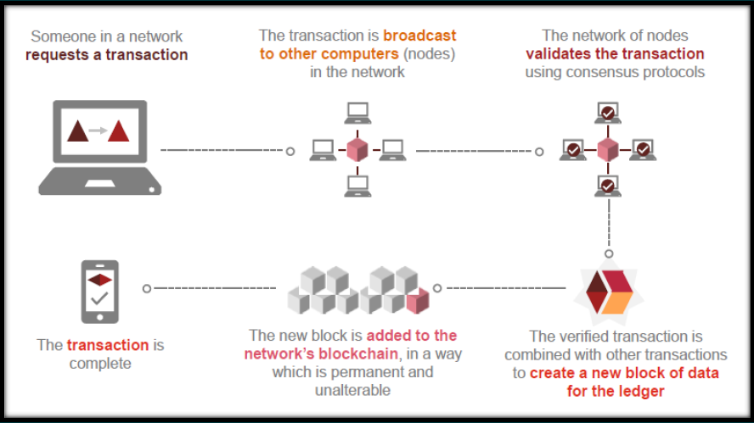

Figure 1. Understanding Blockchain – The Process

Understanding Blockchain – The Technology

There are three principal technologies that combine to create a blockchain. None of them are new. Rather, it is their orchestration and application that is new.

These technologies are:
1) Private Key cryptography,
2) A distributed network with a shared ledger and
3) An incentive to service the network’s transactions, record-keeping and security.

‘IT Staffing using AWS and Bigchain Db solution’ is a unique methodology using blockchain platform for the recruitment process. We are aimed to disrupt the recruitment market. With the help of WORK tokens and Ethereum blockchain technology, we will help people find a better job, and companies to select the most competent employees.

- Major Problems in IT Staffing:

As of today, there may be three major difficulties in the recruitment for businesses:

- It is hard to hire good employees.
There are two reasons for this: it is difficult to find them and it is not always possible to assess them correctly

- High expenses of the recruitment.
The average cost of hiring a new employee for medium level job is about quiet high.

- The complication of candidate’s assessment.
It is not always possible to evaluate the professionalism of the applicant since the data is unreliable. A person can write on the resume and tell in the interview about himself anything he/she wants.

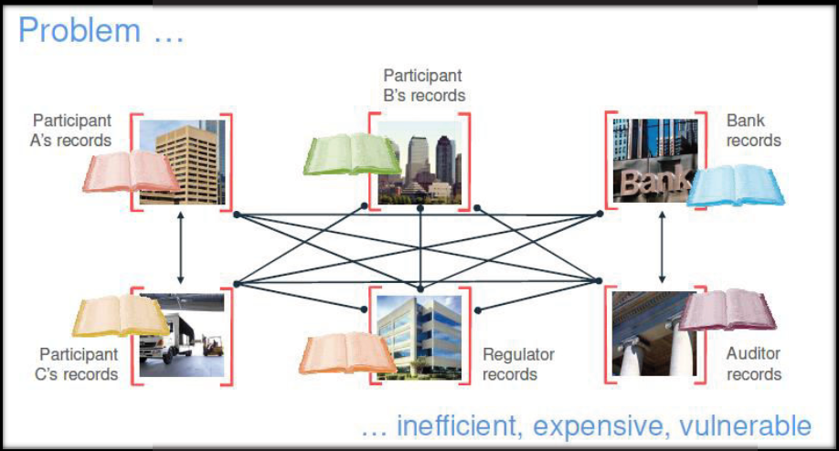

Figure 2. Understanding Problems in IT Staffing

General problems for job seekers:

1. finding a job is challenging due to high competition. Even outstanding, talented specialists sometimes don’t get an offer because of the amount of CV that recruiter receives.

2. Companies use data about people's professional skills for free. People are not paid for the information which they share on social networks, such as LinkedIn or Facebook.

- The Blockchain Proposed Solution:

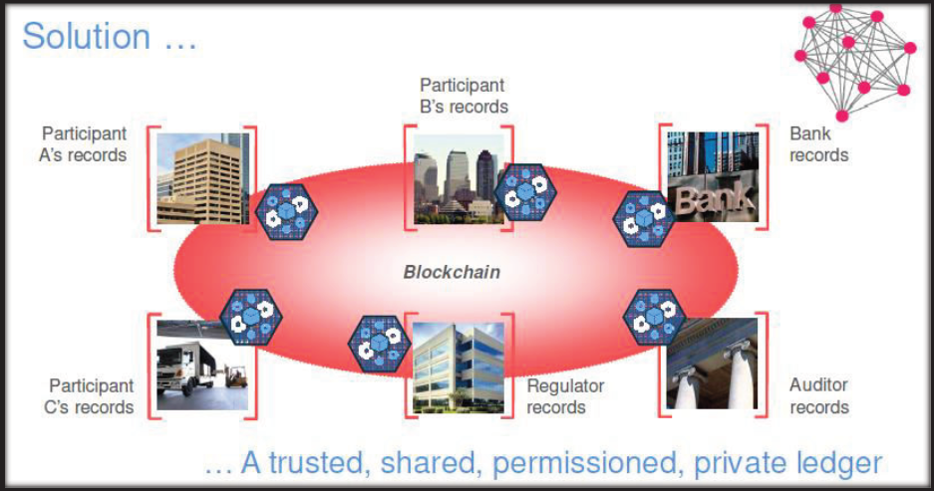

Figure 3. Understanding Blockchain Proposed Solution in IT Staffing

‘IT staffing using AWS and Bigchain Db solution’ is created to help:

1. People get a job faster and with more preferable conditions

2. Companies hire the best candidates and reduce costs per hire.

We use Blockchain technology to create:

• P2P platform for personnel recruitment. With the power of smart contracts, it is possible to change the rules of recruitment, when other people recommend candidates and all participants of critical stages receive a reward.

• Reputation system, which will prove the qualification of specialists.

- ‘IT Staffing using AWS and Bigchain Db’ solution

We are creating a decentralized and reliable solution for employees and companies based on the Ethereum blockchain with smart contracts. Our solution consists of a job marketplace, skills verification and an independent rating of reputation. Employees get the opportunity to find a job and make money on their network, skills and professional achievements. Companies get access to a decentralized rating and skills verified via smart contracts.

b. Our Vision & Mission

- To create the universal decentralized system of employees’ assessment and
reputation for the whole world.
- To create a simple and reliable tool to verify reputation for a couple of clicks.
- To enable people to make money on their skills to have additional motivation for
the development («upgrade the professional skills»).
- To create a decentralized ecosystem that will give employees additional offers and
motivation for the development.
- To enable an employee to become the best in the professional field.
- To introduce the advantages of Ethereum smart contracts to the real world.
- Use Free Resume Builder in the development

  - Decentralized Job Marketplace [Block I]

Using the Job Marketplace, employees will be able to:

- Receive a reward for friends who will work for the company;
- Receive a reward for acquaintances who will be invited to an interview for the company;
- To see at every moment the status of the hiring process

  - Decentralized Skills Verification System [Block II]

Using the Skills Verification, employees will be able to:

- Receive reward for their proven skills.
- Increase their competence in the eyes of HR managers.
- To use the decentralized Reputation Building System which will confirm the real skills of a person on a global scale.

We create a transparent verification system having credibility among the companies. It will be decentralized, universal, transparent, and will offer a list of employees’ skills suitable for a job.

    - How the process works

Every time an employee’s skill is confirmed, information about it will be saved on the blockchain. Then an employee can be shown advertising messages because of verified skills. An employee will receive part of the advertising budget. We will not act like some other platforms and social networks that earn money by reselling data to the other companies. If you own something that a company needs, you have rights on the part of the advertising budget.

    - What can be verified

An employee can confirm two types of data:

1. Skills that prove employee’s value and may eventually be interesting for companies. For example, foreign language knowledge, advanced training courses, knowledge of professional tools and programming languages, etc. The skill test is performed using a supporting document (certificate, video, etc.) and community voting. In some cases, testing will be used instead of the document.

2. Work experience and education. The companies an employee used to work for, and the projects he/she used to be involved in are mentioned. This is one more opportunity to receive reward. A company may be looking for the professionals who used to work, for example, for Microsoft and are currently looking for a job. If an employee meets the requirements, he/she will be able to see the information about this vacancy on a worker.

  - Decentralized Reputation System [Block III]

Creation of decentralized verified employees’ reputation is a complicated one for several reasons, such as:

- Changing a company, an employee starts everything from scratch.
- Employees should use a single unified system where companies can check their reliability. At the same time, such system should be decentralized. This will guarantee independence and autonomy from companies’ involvement and data reliability, winning trust in the system among business communities.
- At the moment there is no single system to prove employees’ professional competencies and performance.

A decentralized system eliminates this problem.

- In this block we have proposed an honest reputation system winning companies’ trust. Being decentralized, universal and transparent, it will show objective employees’ assessment.

3.5.4. Reducing fraud via the international rating

Employees rating will be available to the registered users. It will help to demonstrate competence and good name to the world. Reviews about companies and employees will give a chance to identify fraudsters among

Unscrupulous employers and employees. Those, who have a higher rating and better points, will be able to prove their good reputation and reduce mistrust in job searching phase.

We will promote relations between people and companies to the higher level. We want to create honest and reliable evaluation system so that every employee in small, medium and large business could take advantage of our decentralized system and would have good opportunities to develop their career and improve their life.

3.5.6. Data for Rating

To determine the total coefficient by which the place in the ranking will be determined, the employee should receive an assessment of his performance and competence, community votes and confirm professional skills.

- ‘IT Staffing using AWS and Bigchain Db’ solution Business Model

4.1. Amazon Web Services and Bigchain based platform

To automate of many processes in the recruitment, we want to create a unique Product to help people promote themselves on the market as professionals and create a good standing. We also want to help companies find and hire qualified employees.

AWS Blockchain

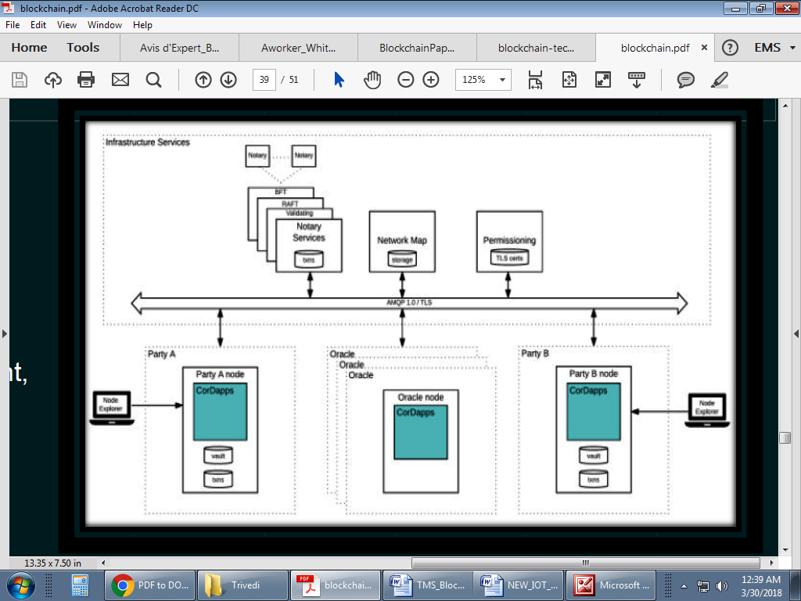

Figure 4. AWS Blockchain modules based Architecture

Amazon Web Services (AWS) has announced a partnership with R3 to allow the company’s Corda platform to allow the company’s Corda

platform to become one of the first ever distributed ledger technology solutions on the AWS. Corda allows users to deploy DApps onto the AWS platform and to create new apps directly. (Dec-2017)

AWS’ acceptance of R3’s distributed ledger technology may signal a future for Amazon becoming friendlier to the nascent but disruptive technology.

- A Co
- rda network is made up of nodes running Corda and CorDapps
- The network is permissioned, with access controlled by a doorman
- Communication between nodes is point-to-point, instead of relying on global broadcasts

As Blockchain helps to solve many problems connected with hiring and reliability of job applicants, our product will consist of 2 parts:

- Application for employees and
- Application for companies

4.1. Application for employees

We want to create a working ecosystem which:

- Will make the job search easier and select most appropriate companies;
- Will build a reputation of a trustworthy employee;
- Will give an opportunity to increase rewards;
- Will advise each employee on more efficient development (upon behavioral and performance analysis);

- Will give an opportunity to purchase partner products with big discounts.

- Will give an opportunity to build the resume in their desired format using free resume builder option which we provide

Decentralization and Blockchain will enable employees to have the following opportunities:

1. Job Marketplace: An employee will have an opportunity to recommend vacancies to friends getting a reward for successful recommendations (got a job or went to the interview). See paragraph 3.3 for details.

2. Skills Verification System: An employee will have an opportunity to add professional skills he/she possesses and get a reward for confirmed skills. See paragraph 3.4 for details.

3. Rating: An employee will have an opportunity to be rated by an independent system for specialists and get rewards of being the best specialist in the country. See paragraph 3.5 for details.

4. Special offers for А–List: An employee will have access to special offers from
partners. We want to create an ecosystem able to provide employees with better opportunities for personal development.

We will integrate other companies into a worker ecosystem to reach this goal. The goal of the partnership is to offer employees special terms (basing on an employee rating and reputation) which are not available on the market.

4.2. Application for companies

Companies will get a platform which:

- will provide access to the reliable database about employees (rating, verified skills, assessment of professional competencies, feedback);

- Will automate routine work while hiring;

- Will allow finding new employees in the application.

Decentralization and Blockchain will enable companies to have the following opportunities:

• Job Marketplace. HR manager will create vacancies so that employees or a worker user have an opportunity to recommend their friends. See paragraph 3.3 for a detailed description of Job Marketplace. Our privilege is providing a chance to earn for all users of the application not only for employees of companies unlike nowadays.

• Automation of recruitment process. It is an application for keeping records of applicants. It keeps the record of communication with candidates. It monitors the effectiveness of HR manager. It communicates directly with candidates from one personal cabinet.

• Database. HR managers will be able to check applicants in a unique database, Our Rating, and see confirmed professional skills of a candidate. This will help an HR manager to rank a candidate and make the right decision based on information from the Ethereum blockchain.

• Advertising. HR managers will be able to use our Db as an additional source to attract applicants. A company will be able to advertise employees with confirmed professional skills. All payments will be provided in WORK tokens. A part of reward will be compensated to employees with appropriate professional skills.

• Presentation of best employees of the company on the website.

4.3. Monetization

We have proposed 4 ways of monetization to create a successful business:
1. Accounts for companies
2. Premium accounts for employees
3. Advertisement
4. Escrow
AWS Blockchain

AWS Marketplace is an online store that helps customers find, buy, and immediately start using the software and services they need to build products and run their businesses. AWS Marketplace complements programs like the Amazon Partner Network and is another example of AWS’s commitment to growing a strong ecosystem of software and solution partners.

Following Blockchain platforms are available in the AWS Marketplace:
Recording and managing the evolution of financial agreements and other shared data between two or more identifiable parties in a way that is grounded in existing legal constructs and compatible with existing and emerging regulation

Choreographing workflow between firms without a central controller

Supporting consensus between firms at the level of individual deals, not a global system

- Deploy new and existing Smart Contracts.
- Data transparency creates trust throughout the supply chain
- Levels the playing field for suppliers and rewards good practices
- Vendors and consumers know what they're getting and get what they're paying for

Conclusions:
Blockchain technology is a sophisticated, interesting, and emerging technology. It provides a reliable way of confirming the party submitting a record to the blockchain, the time and date of its submission, and the contents of the record at the time of submission, eliminating the need for third-party intermediaries in certain situations. The distributed ledger functionality coupled with security of Blockchain along with Amazon Web Services, makes it very attractive technology to solve the current IT staffing issues.
References

http://www.ifc.org/wps/wcm/connect/Industry_EXT_Content/IFC_External_Corporate_Site/Industries/Financial+Markets/msme+finance/sme+banking/msme-countryindicators

http://www.ilo.org/wcmsp5/groups/public/---dgreports/---dcomm/---publ/documents/
publication/wcms_443472.pdf

http://www.ilo.org/global/research/global-reports/weso/2016/WCMS_443480/lang--en/
index.htm

https://medium.com/@wtfmitchel/linkedin–10–million–monthly–active–users–a482e2ecc086

https://github.com/ethereum/EIPs/issues/20

https://www2.staffingindustry.com/eng/About/Media-Center/Press-Releases/Global-

Staffing-Market-Revenue-Growth-to-Accelerate-to-6

https://www.americanprogress.org/wp-content/uploads/2012/11/CostofTurnover.pdf
http://www.bloombergview.com/articles/2013-11-18/are-bitcoins-the-criminal-s-best-friend

